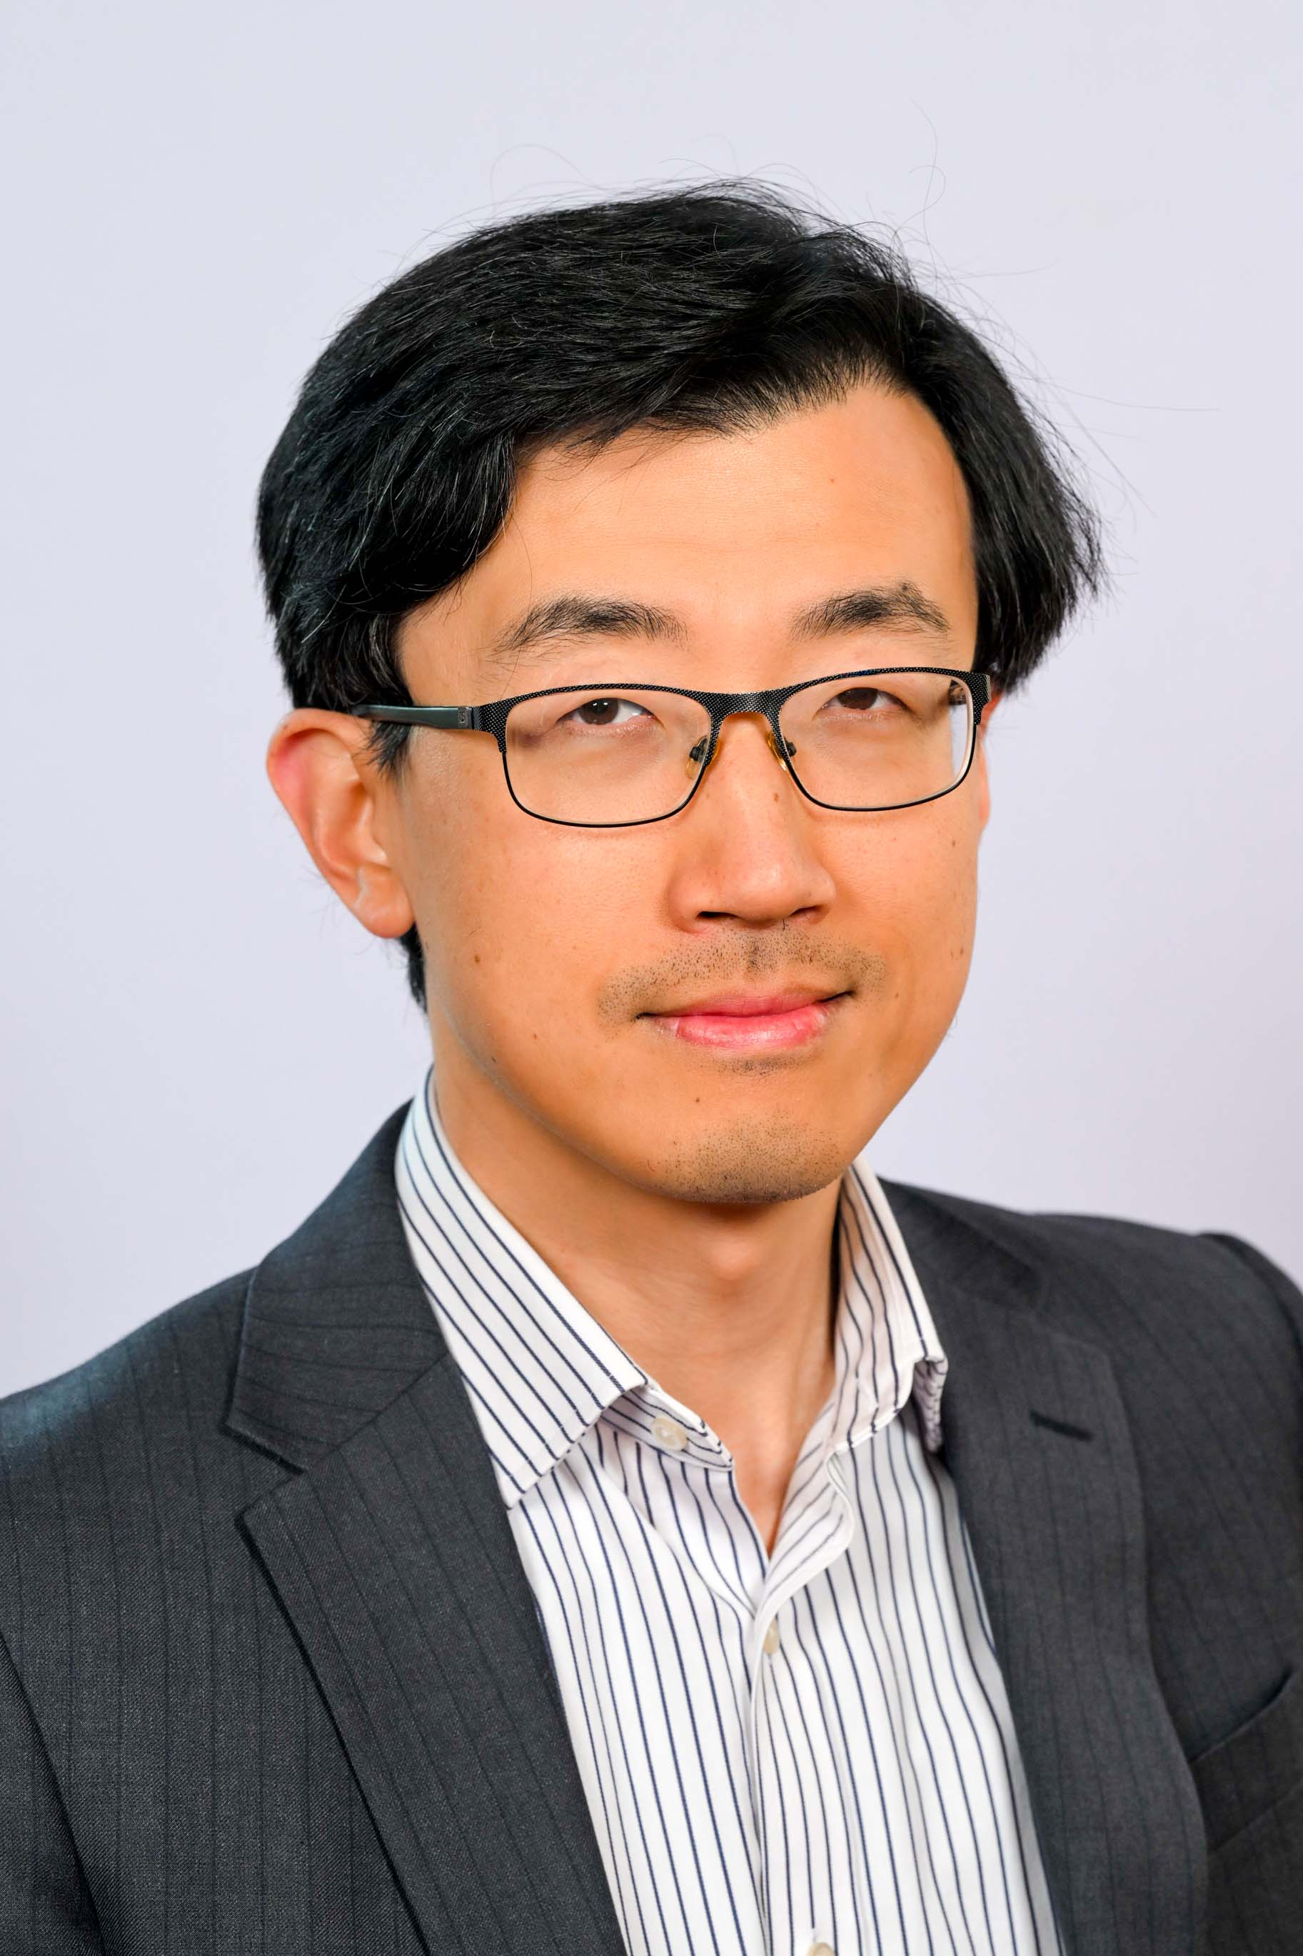
Dr Bo Hu
Chancellor’s Assessor

Dr. Bo Hu serves as Managing Director at Goldman Sachs. He supervises the modelling and risk management of global AI (Artificial Intelligence) and ML (Machine Learning) business, and trading models in Goldman Sachs' global markets business. His prior position is with UBS investment bank on quant research in interest rate, inflation and emerging markets. Bo obtained his PhD degree from University of Oxford, and first degree from Tsinghua University.

